**Project Name: CorHealth**

**Group Members:** Jingwen Zheng, Lanlan Zhang, Sinn Munn Siow, Jiehe Huang, Mengjie Yang, Xi Li

**Introduction**

This project is designed to find the chance of getting cardiovascular disease, correlations of potential causes, trends and any clear indications of heart health based on users’ personal and health behavioral information.

**Welcome Page**

When using our program, we will display the options in the menu for users to choose from, including understanding the attribute correlation to cardiovascular disease, obtaining key attributes analysis, and getting prediction based on their personal information.

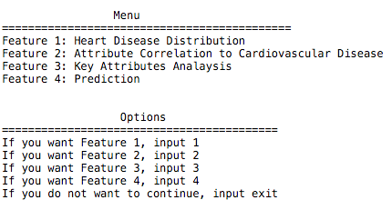

Please download the “cardio_train.csv” file.

**Feature 1**

Before performing analysis, our program will show users the percentage of people with cardiovascular disease versus people who do not have cardiovascular disease. 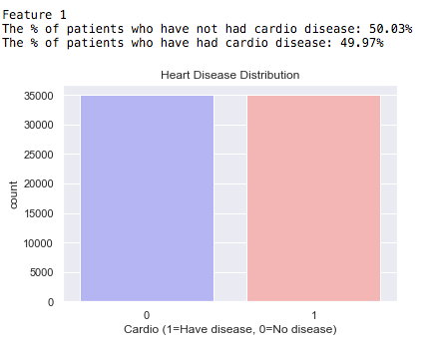

**Feature 2**

Our program used collected data to build a prediction model.

Our model will display the most important driven factors for getting cardiovascular disease.

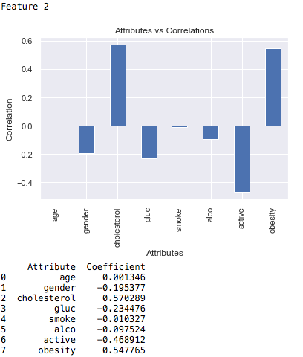

**Feature 3**

Based on the results from feature 2, our model will display the visualization of three most important factors (gender, cholesterol level, and active level) that lead to cardiovascular disease.

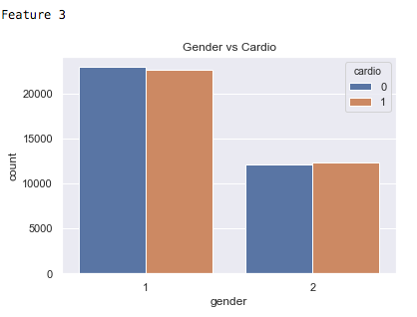

From this graph, we can see that females would have higher chances of getting cardiovascular disease.

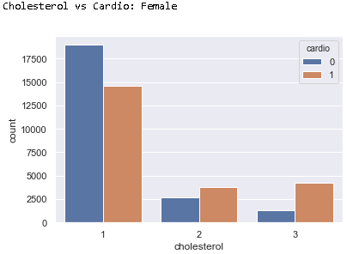

From this graph, we can see that females who have higher level of cholesterol level would have higher chances of getting cardiovascular disease.

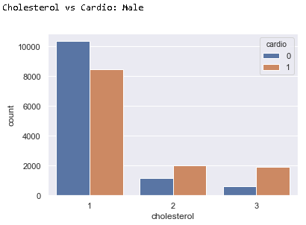

From this graph, we can see that males who have higher level of cholesterol level would have higher chances of getting cardiovascular disease.

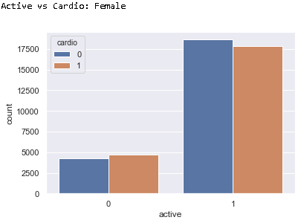

From this graph, we can see that females who do not work out would have higher chances of getting cardiovascular disease.

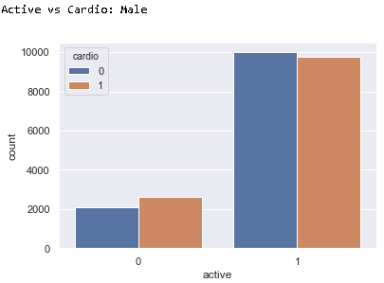

From this graph, we can see that males who do not work out would have higher chances of getting cardiovascular disease.

**Feature 4**

Users who want to predict the probability of getting cardiovascular disease need to enter their age, gender, height, weight, cholesterol level, glucose level, whether they are smoking or not, drinking alcohol or not, and staying active or not. Based on their input, our model will analyze the information and perform the prediction, showing a result of prediction.

